# Google sites analysis using Google Analytics

## Name: - Divit Mahajan

## Sap Id: - 500096565

## Google sites:-

Google Sites is a website builder platform provided by Google that allows users to create and publish websites without requiring any coding or web development knowledge. The platform is integrated with other Google services, such as Google Drive, Google Docs, and Google Sheets, making it easy for users to add content, images, and other media to their websites.



Link- <https://sites.google.com/view/living-conversation-divit/living-conversations>

## Reports snapshot:-Screenshot 2023-04-20 at 10.51.26 PMScreenshot 2023-04-20 at 10.53.35 PM

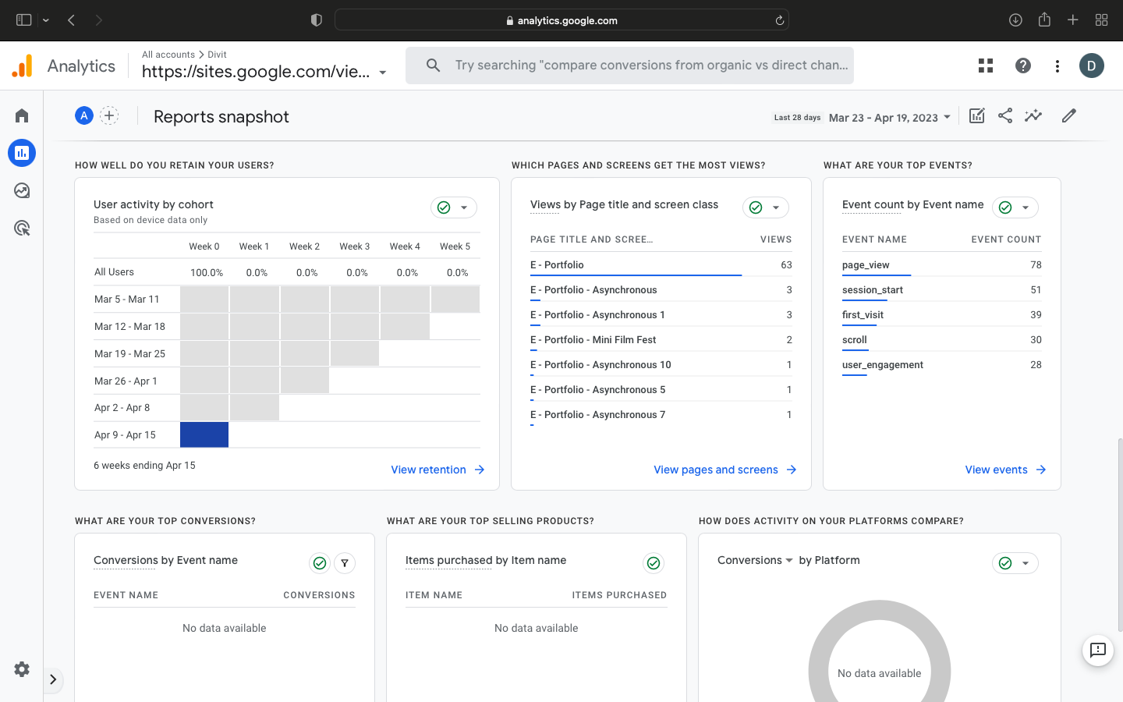

## Demographics overview:-

The demographics overview in Google Analytics provides insights into the age and gender of your website visitors. It allows you to understand your audience better and make informed decisions about your marketing strategies.

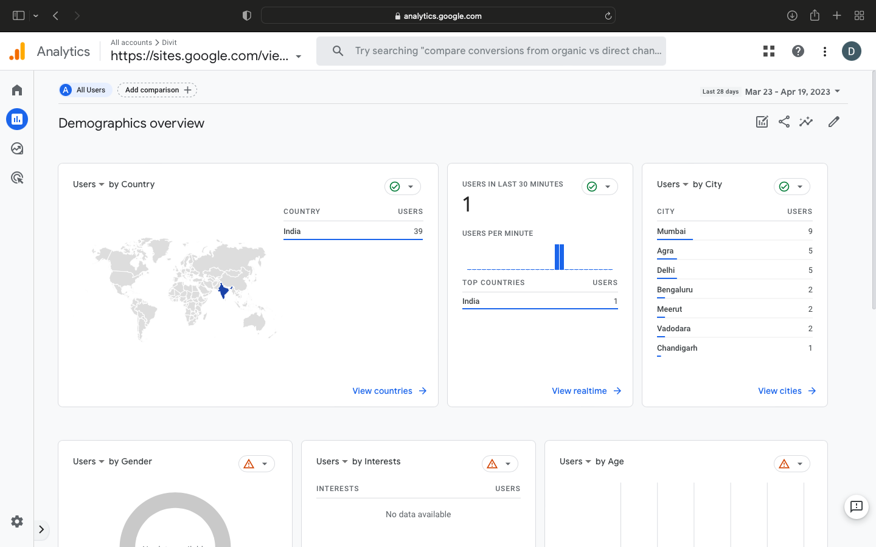

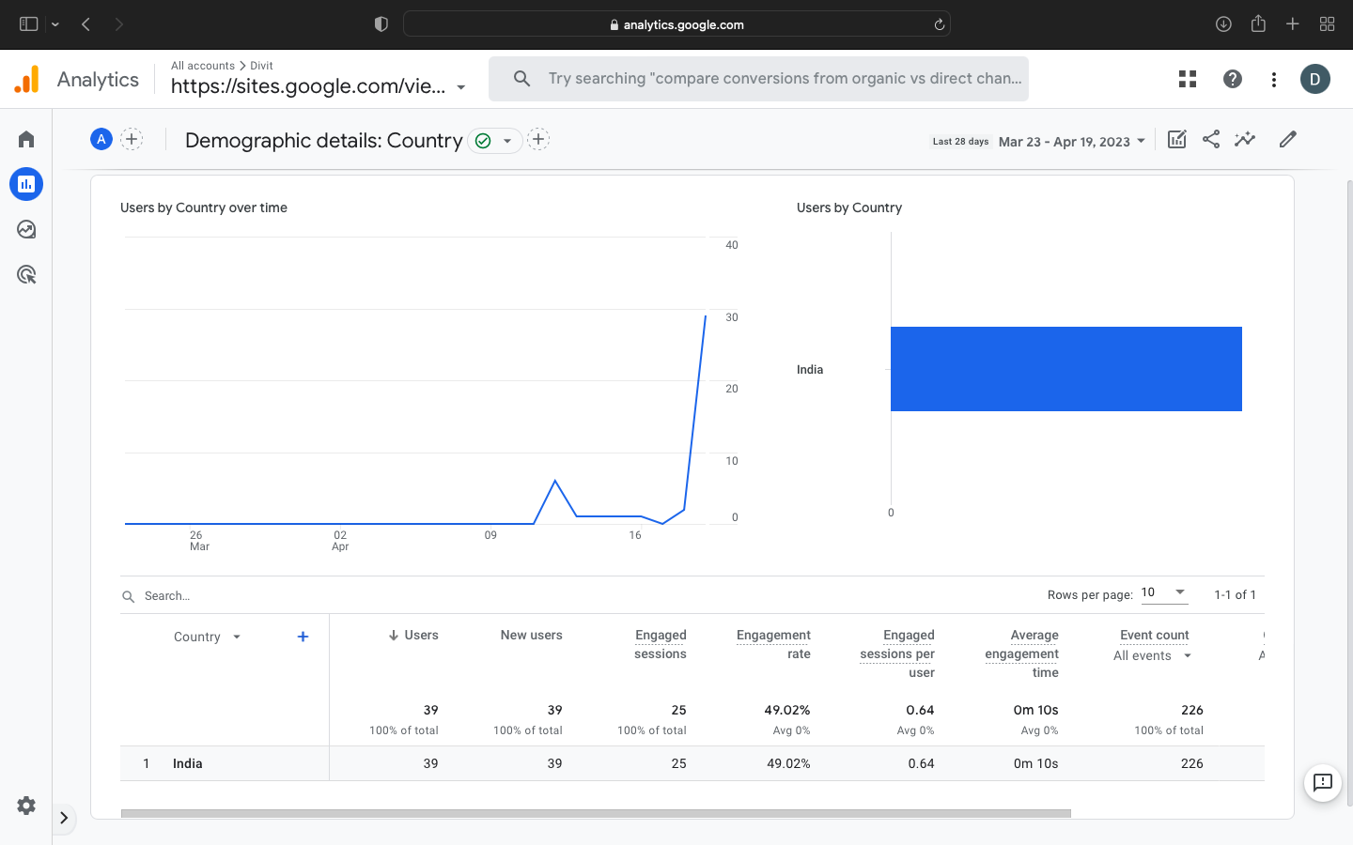

## Engagement overview:-

The Engagement Overview in Google Analytics provides insights into how visitors interact with your website. It allows you to see how long visitors stay on your site, how many pages they view, and how often they return.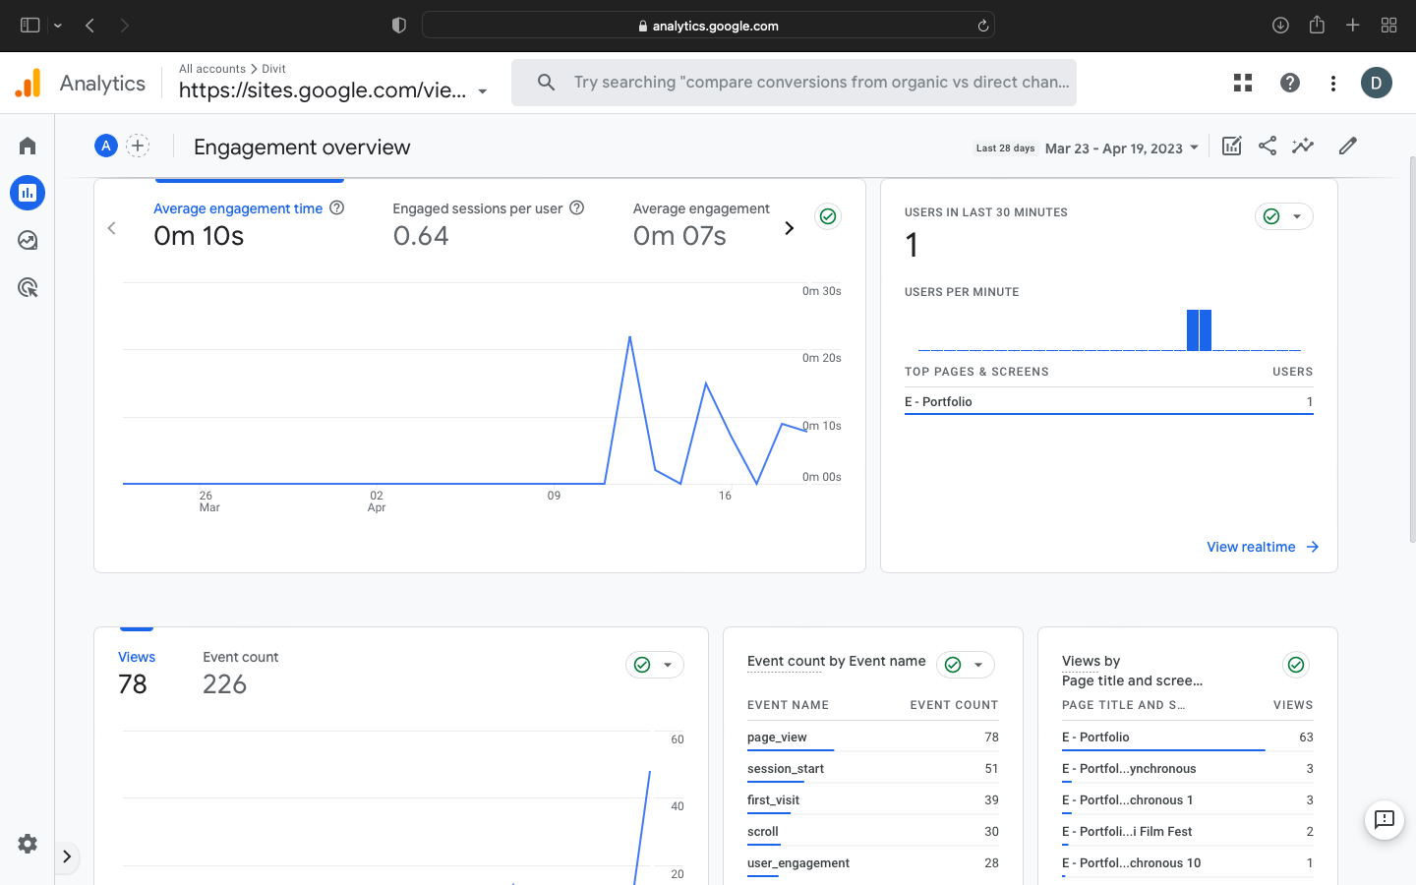

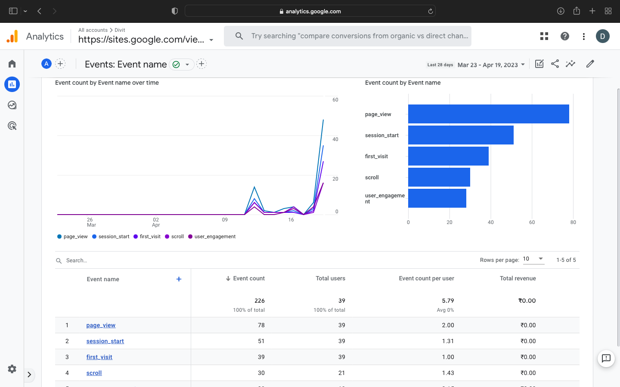

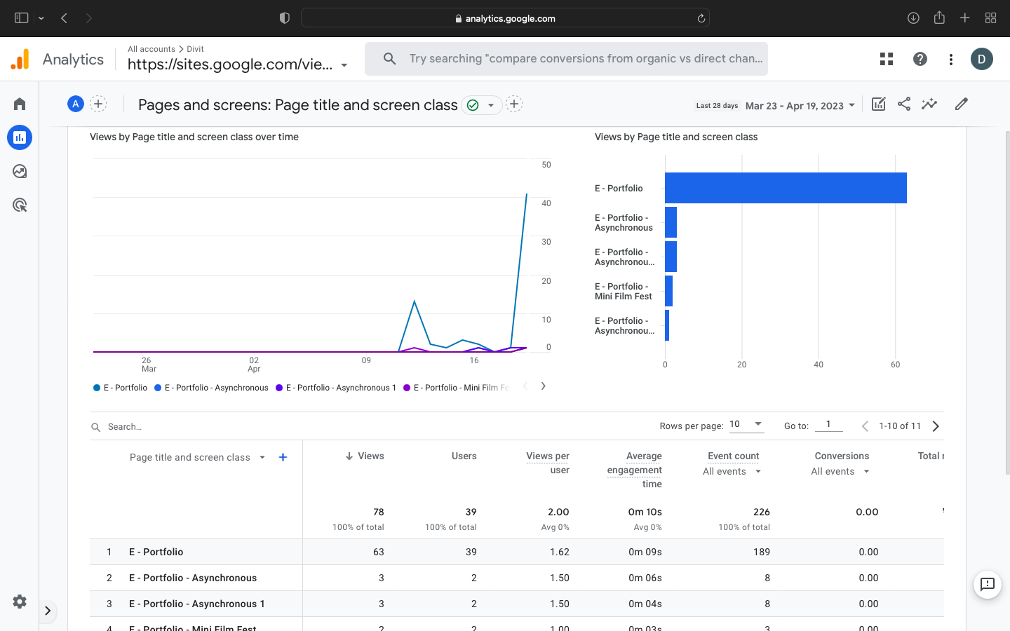

## User acquisition & Real Time Overview:-

The User Acquisition Overview provides information about where your website traffic is coming from, including organic search, direct traffic, social media, referral traffic, and paid search.

The Real-Time Overview, on the other hand, provides real-time data about the activity of your website visitors, including the number of active users on your site, the pages they are viewing, and the geographic location of each user.

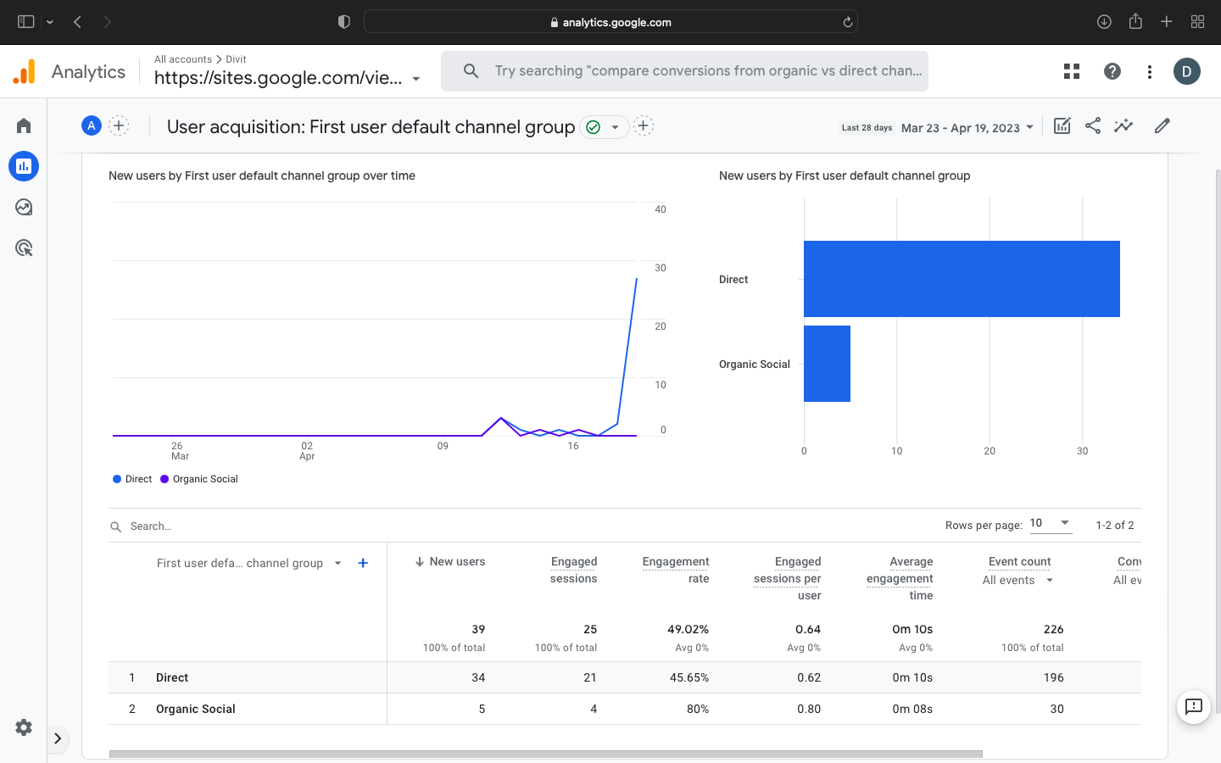

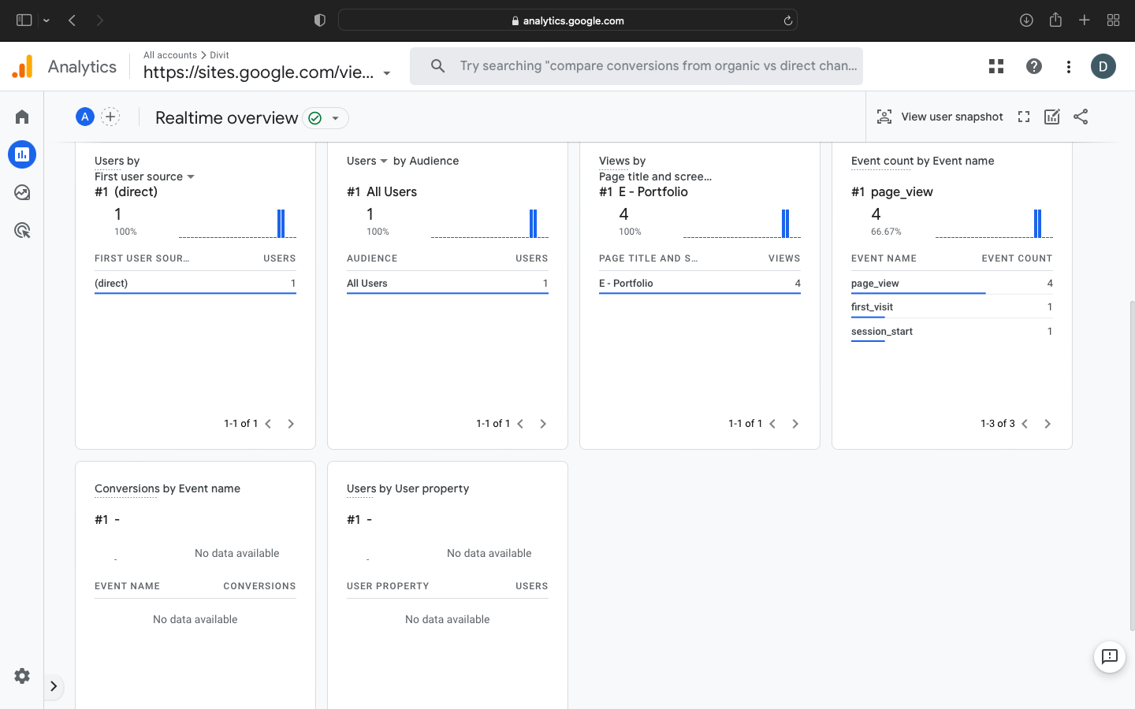

Here are some of the different types of reports by Google Analytics:-

1. **Audience Reports:** This report provides insights into the demographic and geographic characteristics of your website visitors, including their age, gender, location, and interests.
2. **Acquisition Reports:** This report helps you understand where your website traffic is coming from, including search engines, social media, email campaigns, and other referral sources.
3. **Behaviour Reports:** This report shows how users interact with your website, including which pages they visit, how long they stay, and what actions they take.
4. **Conversion Reports:** This report tracks user actions that result in a conversion, such as completing a purchase or filling out a contact form.
5. **E-commerce Reports:** This report provides insights into your online store’s performance, including sales data, product performance, and customer behavior.
6. **Real-Time Reports:** This report provides up-to-date information about your website’s activity, including how many users are currently on your site, which pages they are visiting, and what actions they are taking.
7. **Custom Reports:** This report allows you to create customized reports that are tailored to your specific needs and goals.